HOW TO CREATE A LEVAIN (aka starter/culture)

DAY #1 – initial mix – combine – let sit 24 hours
150g | Rye Flour | - Whole grain organic is ideal  - unbleached flour necessary  - mix ingredients loosely to shaggy mass - cover loosely  – let stand at warm room temp (75F-80F) – 24 hours
185g | Water
5g | Honey

DAY #2 – two feedings – every 12 hours w/ mixed flours
100g | Initial Mix | - measure 100g of your initial mix & combine with remaining ingredients to shaggy mass – cover loosely  -- repeat after 12 hours intervals using last batch not initial mix in order to carry this process forward  -- (so 2 feedings at these ratios on the second day)
45g | Rye Flour
45g | White Flour
115g | Water (90F)

Day #3,4,5 – two feedings – every 12 hours w/ white flour only
100g | Prev. mix | - repeat this feeding cycle roughly 12 hours apart (ie feeding twice a day), for next couple days (ie 6 days), in warm 75-80F environment  - it is ready for use after the 6th day
90g | White flour
115g | Water (90F)

On the 6th day your starter should be alive and well, demonstrating clearly visible bubbling, with good ebbs and flows of growth and receding between each cycle.

Once your culture has completed it’s 6th day feeding, it is considered a mature culture, and needs to switch to a different feeding schedule once made

MAINTAINING A CULTURE - REGULAR FEEDING once a starter is made
160g | AP flour | - once your starter is made – we need to feed it regularly to keep it alive – but the timing will depend on your production schedules and or temperature of room  -- the warmer your environment, the quicker it “proofs”
150g | Water (cold)
30g | Culture

The timing associated with feeding and maintaining a culture (vs starting one from scratch) is less time specific, or frequent. Once created we can slow down the process of feeding so and thus minimize waste.
      - This growth control is achieved through two primary principles, namely:
  - The temperature of the given environment
    - The warmer your environment the quicker it will “proof”
  - The amount of starter to food ratio
    - The higher the starter vs. food ratio the quicker it will ferment
WAYS TO SLOW DOWN your feeding cycles
(to minimize waste)

#1 - COOLING DOWN YOUR STARTER’S ENVIRONMENT
- STANDARD ROOM TEMPERATURE – 21ºC -26oC (60-80F)
  - The warmer your environment the quicker yeasts proliferate
  - Yeast is most active between 85F and 105F
- COOLER/CELLAR ROOM TEMPERATURE - approx 15ºC-20ºC (60-70F)
  - We often maintain our cultures and build our polish or preferments in cooler (ie cellar) temps because:
    - it is easier to control/predict and time
    - It makes for better flavours (hotter = more volatile compounds)
- FRIDGE TEMPERATURE – approx. 4ºC – 40ºF
  - The moving of a starter to the fridge is not for proofing; but for “saving” for later. At fridge temps the development of yeast is slowed or retarded to the point that we stop to see new growth (ie partially suspended)
    - The cooler the environment the more its growth is retarded…
  - This is a major shock to the yeast as it fully suspends yeast development
    - This is commonly done as a last resort if unable to maintain your culture over extended periods (ie on vacation)
  - As this is a major shock to the starter it is advised that you plan ahead to bring the starter back to life before using
    - (ie regular 1-2 FEED CYCLES at room temperature before expecting great bread results from a refrigerated starter)
- FREEZER TEMPERATURE – 0ºC (32ºF)
  - This is the most efficient way to limit yeast production, but not necessarily the most effective, as it comes with serious risks.
    - By freezing we prevent yeast access to water (which is now frozen) thus fully suspending its production to a halt.
      - However, at these extreme temps we also risk potentially killing of microbial yeast bacteria
  - I would prefer putting in fridge and risking starting from scratch before placing my starter in the freezer; but it is a practice used by others.

#2 - CHANGE THE FOOD TO STARTER CULTURE RATIOS
- The first thing you can do is make less starter at the same ratios
  - You can change the ratio to 80 flour / 75 water / 15 culture accordingly
- SECONDLY – if we add less starter to feed ratio this will take longer to reach the same high water mark.
  - Instead of using 160 flour / 150 water / 30 culture
Use 80 flour / 75g water / 10g culture (10g vs. 15 of the regular ratio)

WHEN TO FEED YOUR MATURE CULTURE
the “high water mark”

You will see that your starter is indeed alive; something you have created from scratch by providing a food source to latent yeast found in an any/every open environment. This “LIFE” however is not necessarily a singular living organism, so much as a functioning ecosystem. It is not one yeast you are feeding, but literally billions of them.

You will see that with regular feedings your starter will build a rhythm of growth and decline; whereby each time it rises then recedes, leaving a high water mark (it’s highest growth point before shrinking – as it’s food source has become depleted). If your starter has reached a high water mark and has begun to recede, it is considered a “mature culture” (ie hungry again) and good to use in either new bread or a carry forward starter.

If we don’t feed our starter (over say the course of a week) it has the potential to die from lack of food source. Conversely, if we feed it too regularly (ie before it has hit its high water mark) it is has not created enough new yeasts, and therefore is not active or hungry enough to pass on and inoculate the next culture (just adding flour to flour with a weak yeast culture). We need to keep this starter alive in perpetuity by feeding regularly.

HOWEVER, if we aren’t making a lot of bread (ie daily or at least regularly) this maintaining of a starter or culture can become somewhat of a wasteful and time-consuming practice. We use the starter to make bread and or inoculate new cultures (ie 30g-100g of 340g at a time) – but the rest that isn’t used in either of those two applications is discarded in the garbage. Thus home cooks (vs. professional bakers) are often trying to minimize this waste between bread production cycles while still keeping an active and vigorous starter alive.

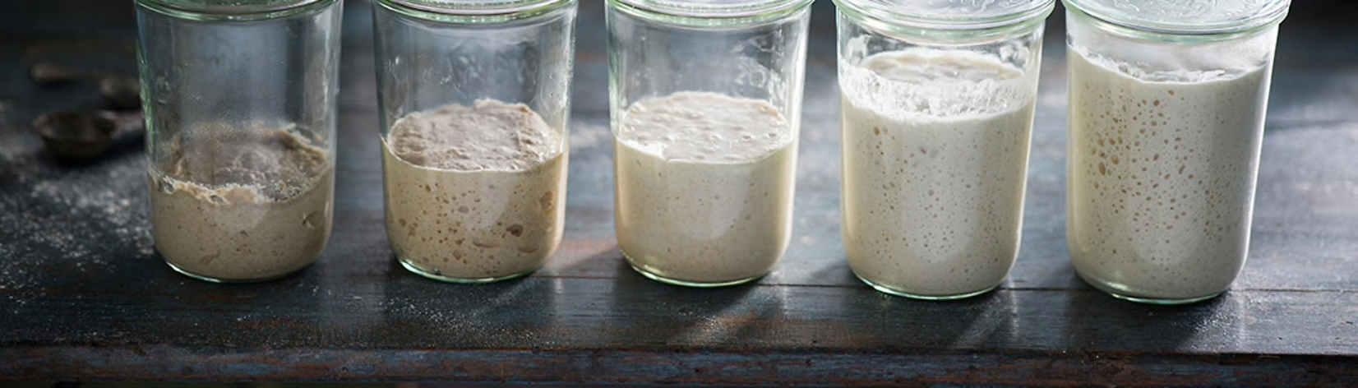
ABOVE IMAGE: growth cycle of a sourdough culture (12-16hrs)  RIGHT IMAGE: demonstration of “high water mark”  -- as the culture grows it will reach high a point at which it cannot grow any more (its food source is depleted); it will begin to shrink or recede. continuing to sour more and more as it rests.  -- this indicates the culture is “mature”, and hungry again, and is now able to be used in bread and / or to inoculate a next culture  -- we don’t need to feed as soon as we see this drop (it can stay hungry for a few days); ideally we want to use just at that mark. | 