EGGS: THE FOUNDATION OF A KITCHEN

COOKING EGGS “101”
Fried Eggs
Scrambled Eggs
Poached Eggs
Sous Vide Egg
French Folded Omelette

PERFECT FRIED EGG “sunny side up” |  |  |  |  | NOTES:  - clarified butter minimizes excessive browning on bottom which can occur with whole butter (solids)
Amt | Ingredient | Prep | TOOLS REQUIRED
2 | Egg | Strained | Strainer | Ramekin
1-2 tsp | Butter | Clarified | Non-stick frying pan
t/t | Salt & Pepper |  | Spatula
METHODOLOGY
- Break one egg into a strainer to remove/separate thin white from thick
-- transfer the strained egg into a ramekin
-- repeat with second (or remaining eggs) – 1 egg per ramekin
- Preheat a non-stick pan to warm but not hot (medium heat ~45 seconds)
- add a small amount of clarified butter – allow to melt – swirl in pan
- Carefully add the egg to the pan, having the ramekin close to the pan (to prevent the yolk from cracking as it falls/hits the pan) – add second or remaining eggs
-- immediately reduce heat – cook on low heat 3-5 minutes until whites are set
- A NOTE ON DIFFERENT DONENESSES
-- if over medium flip after whites are set – cook approx 1.5 min (4.5 total)
-- if over hard – flip after whites are set – cook approx 3 mins (6 total)

For best results – use fresh eggs; strain to separate loose whites; cook lower and slower for control

GORDON RAMSAY  SCRAMBLED EGGS |  |  |  |  | NOTES:  - the end result is a creamy product  -- aided by the addition of dairy which adds richness and cools the temp thus stopping the cooking  - sour cream can be used in sub of crème fraiche
Amt | Ingredient | Prep | TOOLS REQUIRED
6 | Eggs | Whisked | Cut board | Knife
1 Tbs | Butter | Cold cube | Whisk | Bowl
t/t | Salt & Pepper |  | Non-stick frying pan
1-3 tsp | Crème Fraiche |  | Spatula
1 Tbs | Chives
METHODOLOGY
- Crack the eggs into a bowl and whisk to incorporate
- Add eggs to a non-stick pan (10” ideal)
- Add the cold cubed butter to the eggs and turn on the heat (med-high)
- Stir constantly with a rubber spatula (don’t whisk) ensuring to scrape bottom
- After 30 seconds – take the pan off the heat
-- keep stirring off the heat for 10 more seconds
- Repeat this 30 on / 10 off for approx 3 minutes
- In the last minute (after eggs have some texture) season lightly
-- for extra creamy texture fold in the crème fraiche
- Plate on a warm dish; garnish with chives (and or chervil)
https://www.gordonramsayrestaurants.com/recipes/scrambled-eggs/

IN SHELL COOKED / CODDLED EGG |  |  |  |  | NOTES:  - yields a just yet fully set yolk without overcooking (initially or via carryover cooking)
Amt | Ingredient | Prep | TOOLS REQUIRED
6 | Eggs |  | Pot | Lid
 |  |  | Saran | Timer
 |  |  | Ice bath
METHODOLOGY
- Place eggs into a small pot; large enough so they sit in one single layer on bottom
- Fill the pot with just enough cold water to cover eggs by approx ¾”
- Place on element/burner and bring to a full/rolling boil (uncovered to watch)
- As soon as at a full boil – remove from heat – cover with saran & lid
-- set aside off heat / covered – start timer:
-- soft yolk – 4-6 mins
-- medium yolk – 6-8 mins
-- just but fully set – 11 minutes
- ONCE timed – remove from hot water -then store the eggs in reserved ice bath
-- this quick cool method helps to prevent overcooking and minimize oxidization; aka the dark greenish/black ring around the yolk with prominent sulfur aroma
- Once completely cooled in ice bath (15 mins) peel by hand (in water)
-- note if looking for HARD BOILED – simply boil for 8 full minutes ON THE HEAT.

Pierce the large end of the eggs with a pin or needle.  - This pierces the air cell in the egg, allowing the air to escape, which prevents a flat spot from forming on the large end of the egg during the cooking process.  - It also helps to make the eggs easier to peel after cooking. | 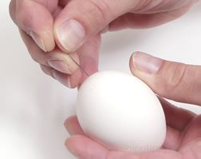

SOUS VIDE – A BACKGROUND:

Sous-Vide cooking developed out of the Nouvelle movement of French Cuisine. As health conscious chefs increasingly shied away from heavy and rich cuisine they moved instead towards a more clean, precise, lower fat, yet still “authentic” way of cooking.

Part of this movement emphasized a returned focus to vegetables on the plate and in the menu. Sous-Vide Cooking developed as a way to showcase commodities in their singular form; unobstructed by other elements… no butter in the pan; not even water from the pot. Cooks, collaborating with scientists and engineers, devised a way to combine the elements of sous-vide pressurization, and the low-temperature cooking precision allowed by immersion circulators.

The Sous Vide aspect is achieved via a chamber vacuum specially designed to pressurize a confined space; extract the air, then seal a commodity free of air, and constantly under pressure until the bag is opened.

Mixing this with immersion circulators, which allow cooks to regulate water temperatures to 1/10th of a degree Celsius; while also creating an artificial current similar to boiling but at much low temperatures; thus creating a fundamentally new cooking method.

The primary purpose of a sous vide, vs say poaching or a slow cooker, is its ability to dial in precise temperature control: to within 1/10th of a degree Celsius. It constantly reads the water temperature and increase or decreases with its own heater and motor (for current) to regulate the temperature in a constant and controlled way.

It is this reason that, so long as we’ve chosen the appropriate temperatures to set, we will never overcook something via sous-vide. Because the cooking medium is never higher than our final cooking temp we can’t “overcook” it. In on a 1000F grill we can easily overcook our steak which we aim to have internally to 125F… in a 125F water bath we cannot overcook it; regardless of how long it stays in the water it will never cook beyond the desired doneness you have programmed.

ARTIFICIAL CONVECTION CURRENT?

As part of our understanding of our medium of heat transfer (water, air oil) we must also understand the way in which heat is delivered in a kitchen (conduction, convection, radiant) AKA means of heat transfer. With boiling, and or any wet method, we are relying on convection as the way that heat is actually delivered to the commodity (moving from hot to cold).

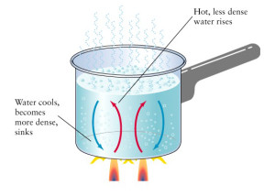 | - as heat is transferred to the pot through conduction, it heats the water which heats and transfers energy to the commodity via convection.  -- as water near burner heats, it rises, cools and returns to the bottom creating a vortex current or convection effect  (see image to left )

The hotter the current the more vigorous the boil, the more efficient the heat transfer.
- BOILING = 212F = full rolling boil
- SIMMER = 180-200 = noticeable to vigorous bubbling
- POACHING = 160-180F = minimal bubbling – barely breaking surface.

SO… boiling water is not only hotter, but also more efficient at delivering that same energy – due to increased currents; than say simmering, or poaching. What sous-vide does is level this playing field. With sous-vide, much like with a convection oven, we have an artificial or man-made current created (not relative to the temperature of the water); so that we can cook at poaching or simmering temp – with an artificially increased current (efficiency).

THE BENEFITS OF SOUS-VIDE

UNIFORM COOKING: The greatest advantage of sous-vide to either the home or the pro cook is uniform cooking. You will get the same result every time regardless of which line-cook is working. Also it will be uniformly good because it is entirely pre-programmed. So long as temperatures guidelines are followed it is virtually fool proof.

LITTLE ATTENTION REQUIRED: because we are cooking at lower temperatures we cannot burn, and because of a zero delta curve we cannot even overcook. We cannot alter it once it’s in the bag so it’s simply a waiting game til done. Sometimes the cooking process is multi-day, allowing you to go home worry-free; so long as there is enough water in the tank to account for any evaporation while you are gone.

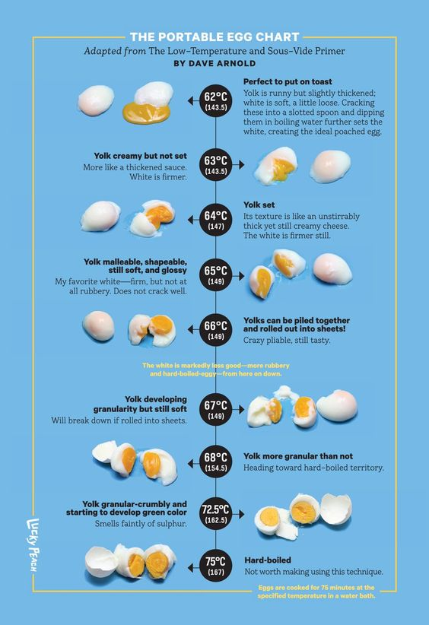

SOUS VIDE EGG |  |  |  |  | NOTES:
Amt | Ingredient | Prep | TOOLS REQUIRED
12 | Eggs |  | Water bath | Sous vide
 |  |  | Long tongs | Timer
METHODOLOGY
- Set bath to 63ºC (145.4ºF)
- Carefully lower eggs in one at a time with long tongs (to prevent shell breaking)
- Allow water bat to return to 63oC (if it drops)
- Cook eggs for 45 minutes
- Remove eggs from bath
- Break from shell (remove white if desired) serve immediately

DOES SALTING TIME REALLY MATTER???

According to Kenji Lopez Alt, author of THE FOOD LAB, when we salt makes a considerable difference on the end result of our delicate eggs. As we can see from the image below, not only does salting in advance cause a considerable effect on the colour (making a deeper, richer, more “farm fresh” appearance), it also makes eggs more tender and fluffy. The reason for this is that by “adding salt to the eggs well before cooking [you] can prevent the proteins from bonding too tightly by reducing their attraction to one another (chemically), thus resulting in a more tender curd less likely to ‘weep moisture.”

15 MINS PRIOR TO  darkest colour  least watery  softest curds  JUST BEFORE  = moderate tender  Moderate water weeping  SALTING NEAR END =  toughest texture of three with highest tendency to “weep” moisture | 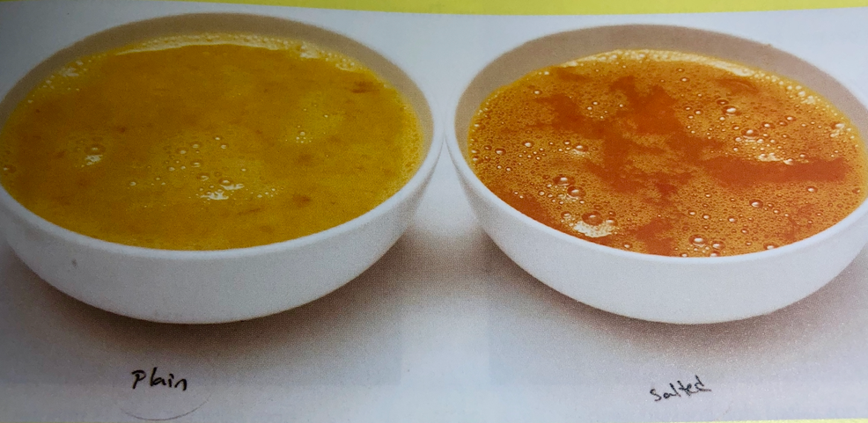  NOT SALTED SALTED  & RESTED 20 mins

TRADITIONAL POACHED EGGS |  |  |  |  | NOTES:  - start water hotter than poaching temp (ie 175F) to account for temp drop as cool eggs are added / water is stirred  - acidulation is important to set proteins
Amt | Ingredient | Prep | TOOLS REQUIRED
3L | Water |  | Pot | Slot spoon
3 Tbs | White Wine Vinegar |  | Ramekin | Shock bowl
1 Tbs | Salt
8 | Eggs
METHODOLOGY
INITIAL COOKING OF EGGS
- Fill a small stainless steel bowl with cold ice water, set aside to store/shock cooked eggs
- Fill sauce pan with at least 6” deep water – bring to a boil
-- add vinegar, salt (1/2 tsp salt and 1 Tbs vinegar per 1L of water)
- Break each of 4 eggs into individual ramekins
-- Straining 1st to separate and remove the loose outer egg white first is ideal)
- Reduce temperature of water to a simmer (175F)
– using spoon spin/stir water to create a water vortex currant in the pot
- Drop eggs one at a time to simmering spinning acidulated/salted water
-- stir water to keep current moving
-- Add 3 remaining eggs in similar fashion
- Start time for 3 minutes – maintain water temp approximately 160-165F
- once poached for 3 mins remove each, individually, using a slotted spoon
-- transfer to ice bath to stop cooking process
- Allow eggs to cool to COLD – continue poaching another 4 eggs
--- continuing process till 16 eggs have been cooked
COOLING / TRIMMING OF EGGS
- Once all eggs have been poached/cooled
-- carefully remove from water one at a time – trim edges to clean up
-- after trimming – return to fresh/cold water – store in fridge until use (reheat)
SECOND COOK / REHEAT of POACHED EGGS – Alternative methods
- METHOD #1 -- Heat tap water as hot as will allow
-- fill a container with hot water – allow eggs to come to temp approx 12 mins.
- METHOD #2 - Bring fresh water to simmer (175) with only salt (no vinegar)
- Remove eggs from fridge cold water
- Reheat eggs, several at time, in fresh salted water (160) for approx 2 minutes
- Take out one at a time – dab on cloth to remove excess moisture before plating/using as a hot poached egg (with oozy liquid center)

SOME NOTES ON THIS RECIPE:
- Acid in the recipe helps set/coagulate the proteins that set at a lower temperature in poaching temps (160-180F) than they do when boiled (212F)
- Stirring helps promote convection; create the pouche or pocket effect we know/see with a well-made poached egg
- Use the freshest eggs possible; and or strain to remove loose white
-- “loose whites” or tails can also be trimmed up between first and 2nd cooking also.
FRENCH FOLDED OMELETTE |  |  |  |  | NOTES:  - clarified butter prevents unwanted browning to occur from milk solids
Amt | Ingredient | Prep | TOOLS REQUIRED
3 | Eggs |  | Bowl | Whisk
1-2 Tbs | Butter | Clarified | Frying pan | Spatula
t/t | Salt & Pepper |  | Clean towel
METHODOLOGY
MIXING OF THE EGGS
- Mix eggs with fork or whisk till frothy – season with salt and pepper – let rest 20 mins
HEATING OF PAN / ADDING OF BUTTER
- Melt butter in omelette’s pan, (10” non-stick); allow to melt/coat all edges med-high heat
-- we use clarified butter to prevent browning
-- we don’t want the pan excessively hot either.
ADDING THE EGG / STIRRING/SETTING THE CURD
- Add eggs and stir briskly with spatula in circular motion – then reduce the heat to medium low
- Once a curd begins to form neat the bottom of the pan – quit stirring
-- to fill nooks/crannies lift pan off heat – and begin tipping pan to allow uncooked loose egg to fill the empty parts of the pan
- Continue cooking on lower heat until bottom close to set and exposed egg still largely runny – if adding a “filling” do so in the middle at this point.
FOLDING THE OMELETTES
- Hold pan handle in one hand – so that the handle is at 3 o’clock
-- (9 o’clock if left handed)
- Give handle a sharp tap with other hand
- Begin to book fold the omelet – so one third (handle side) moved towards the middle third of the omelets
-- tap with wrist again
- Then, slowly, while tilting, begin to lift handle so the double edge omelet begins sliding out (away from handle) – forcing the unfolded omelet up on the pan edge
-- then using your spatula begin to carefully fold this over the other to complete the book or tri-fold process
REMOVING THE OMELETTES FROM THE PAN
- Move your plate close to your pan, then gracefully yet forcefully Inverting pan upside down(moving the pan from 3 to 9 o’clock, spilling the omelet on to the plate with the new fold and seam side down
- Using a clean cloth shape this omelettes into an elliptical “Cat Eye” shape
-- brush with additional clarified butter and garnish with herbs / chives etc.
https://www.youtube.com/watch?v=qXPhVYpQLPA
WATCH POINTS – to MAKE OR BREAK THE DISH
- finely integrated colour (no white blotches) – no colour or browning from over cooking
- smooth runny curd / custardy like on the interior – with proper seasoning
- multiple defined layering / proper folding
- smooth shine and exterior with proper shape and elliptical aesthetic
- no excess fat on plate – or mess aside from omelet in any way.

